Set Up Amazon SNS
- Open the Amazon SNS Console.
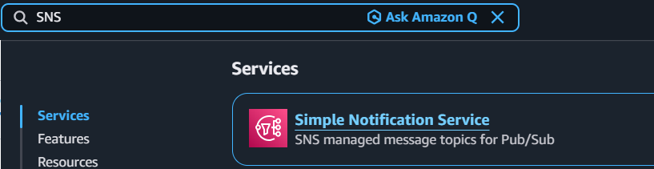

- Click Topics on the left menu and select Create topic.
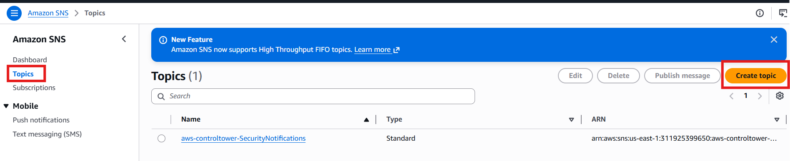

- Choose Standard as the type.
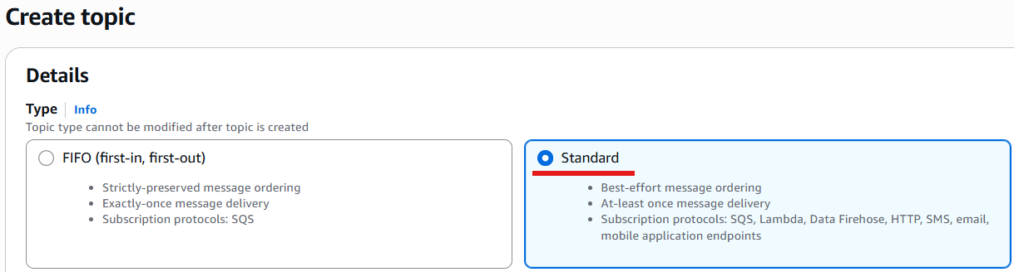

- Enter a name EC2-State-Change-Topic, remaining as default and click Create topic.
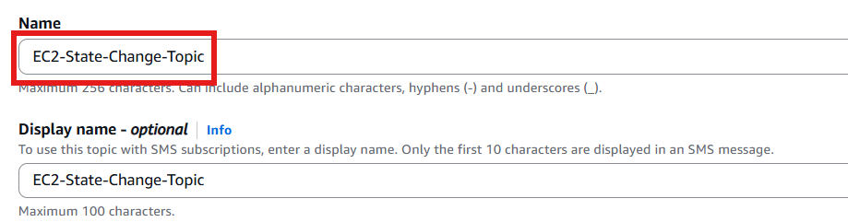
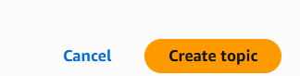
- Topic successfully created and Note the ARN for reference.
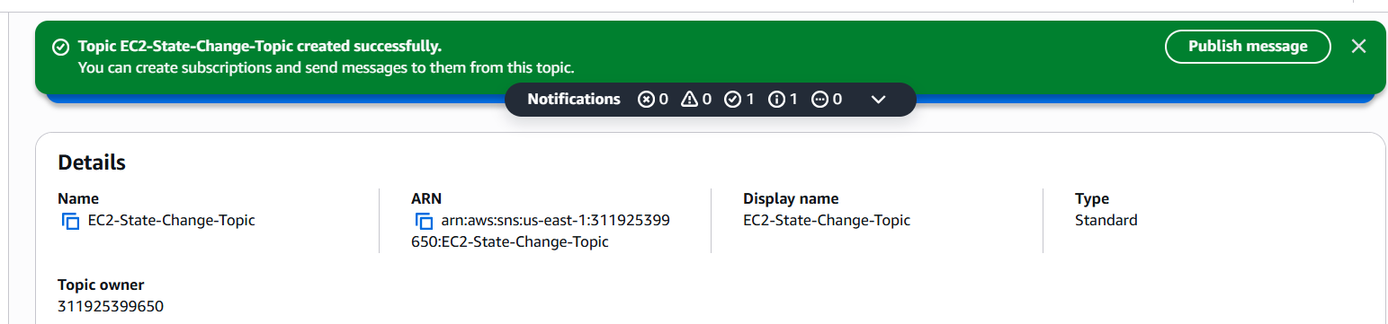

- Click Create subscription under the subscriptions tab.
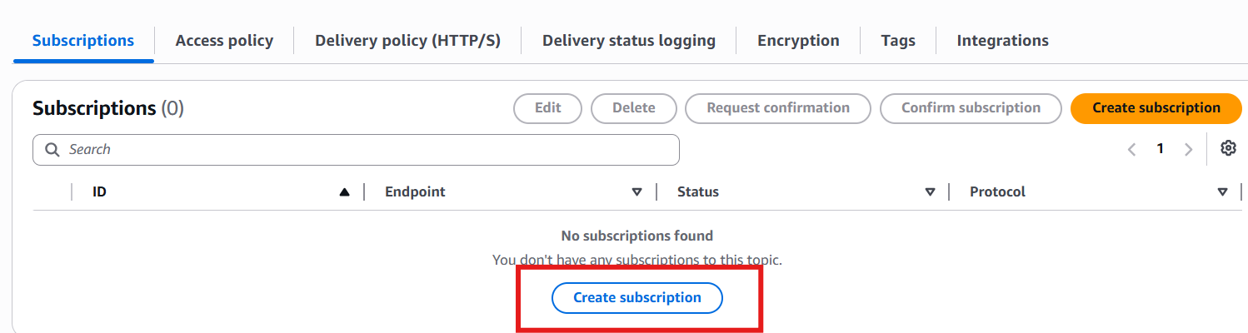

- Set Protocol to Email.
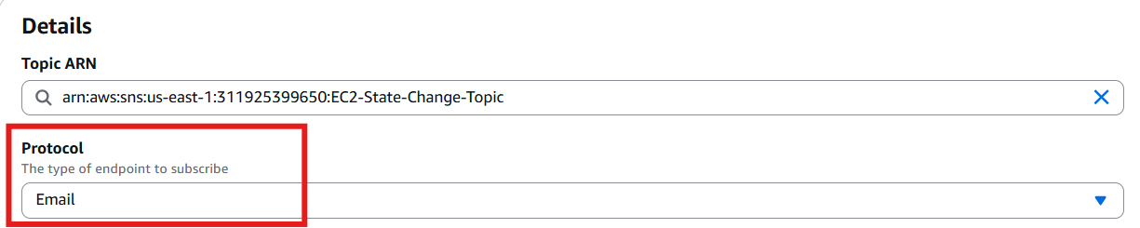

- Enter your email address in the Endpoint field, remaining as default and click Create subscription.
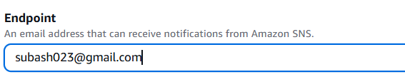
- Subscription has been created successfully.
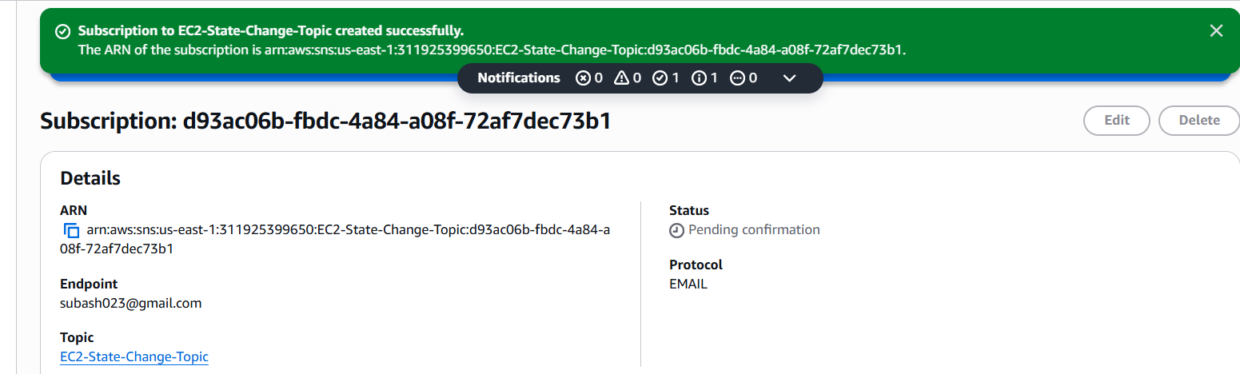
- Check your email inbox, open the confirmation email, and click Confirm subscription.
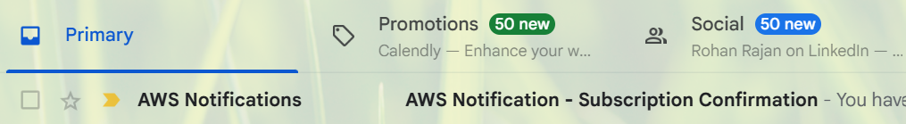
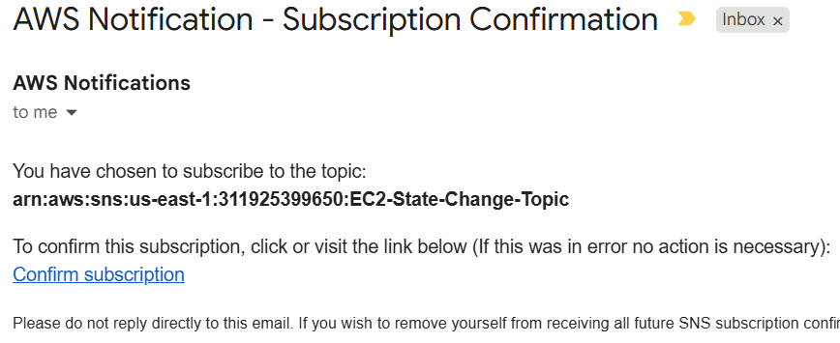
- Confirmed Subscription successfully.
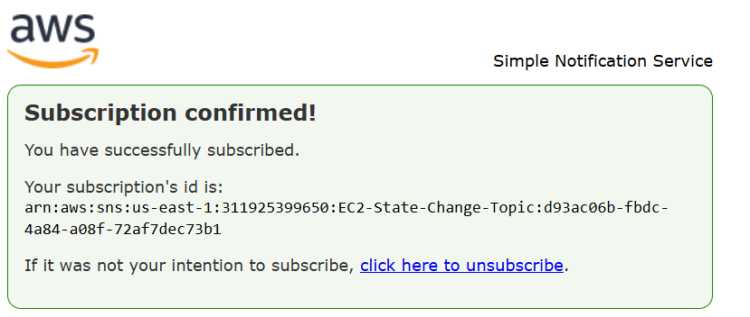

Copied my new Topic ARN from the topic details for later use
arn:aws:sns:us-east-1:311925399650:EC2-State-Change-Topic

Configure Lambda IAM Role
Before writing the function, the Lambda execution role needs permission to send emails via SNS topic.
- Open the IAM Console.
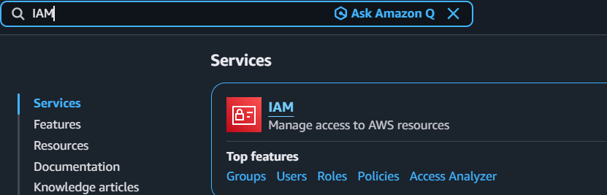
- Go to Roles and click Create role.
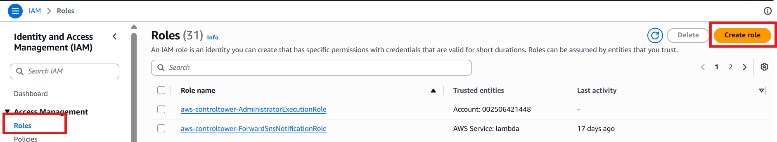

- Select AWS Service and pick Lambda as the use case can click next
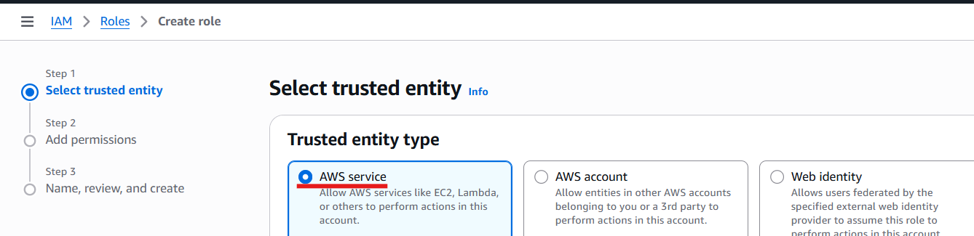
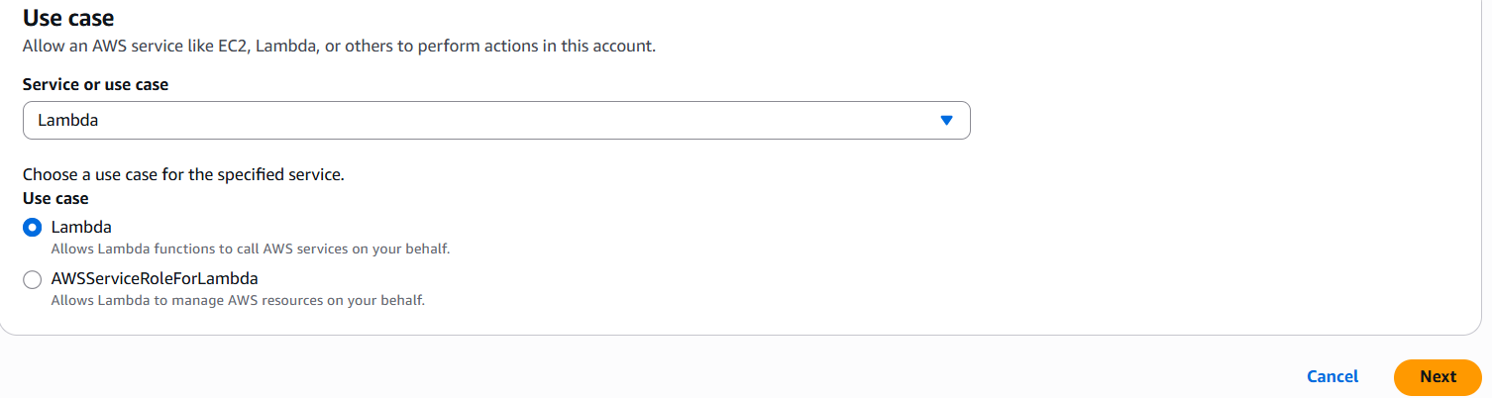
- Search for and check the managed policy AWSLambdaBasicExecutionRole (this allows CloudWatch logging).
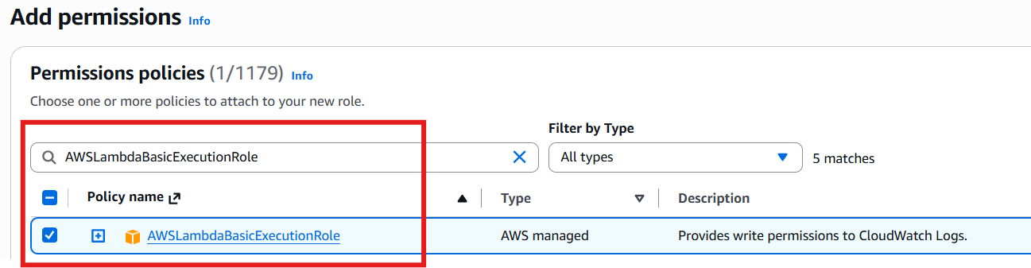
- Complete the steps to name and create the role Lambda-EC2-SNS-Execution-Role.
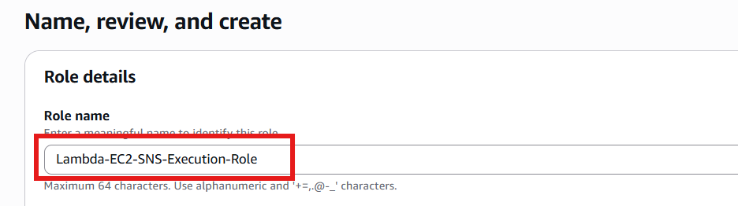
- Click on your newly created role, choose Add permissions, then select Create inline policy.
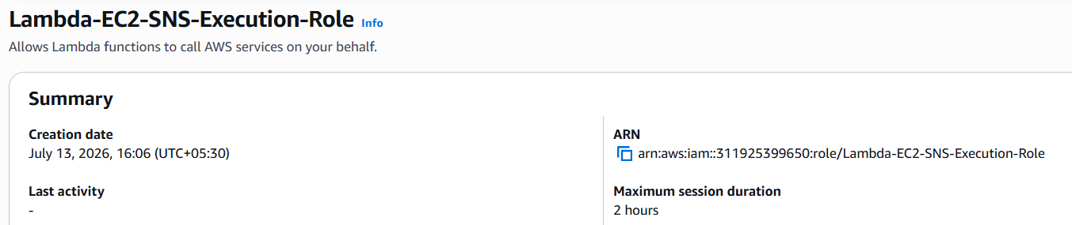
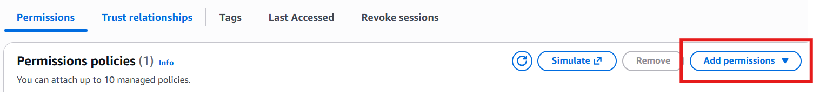
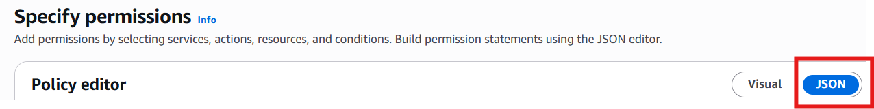

- Edited with the following code in JSON configuration with my actual Topic ARN:
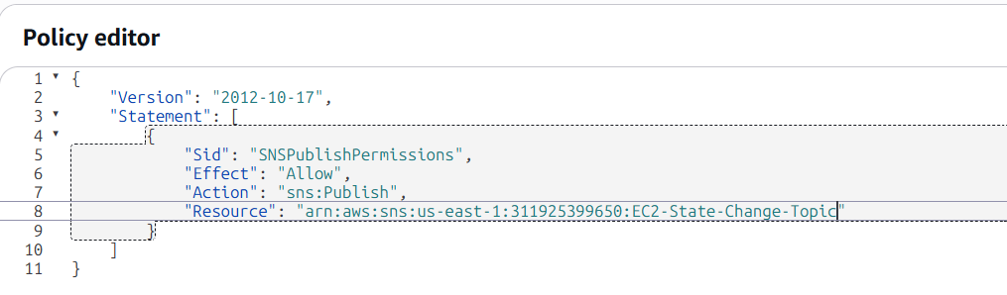

- Name the policy LamdaSNSPublishPolicy and click create policy.
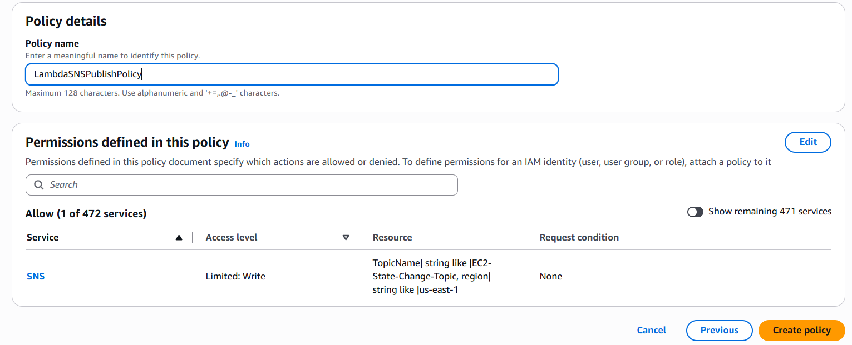

Create and write the AWS Lambda Function
- Open the AWS Lambda Console.

- Click Create function, choose Author from scratch, and select your preferred runtime (Python 3.12 or Later).
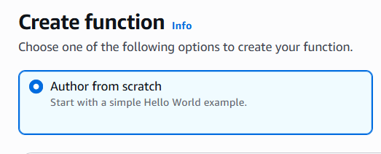
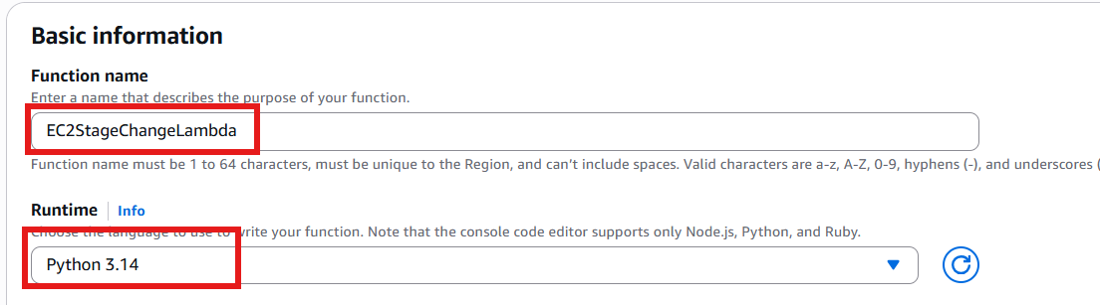

- Under Permissions, choose Use an existing role and assign the IAM role created
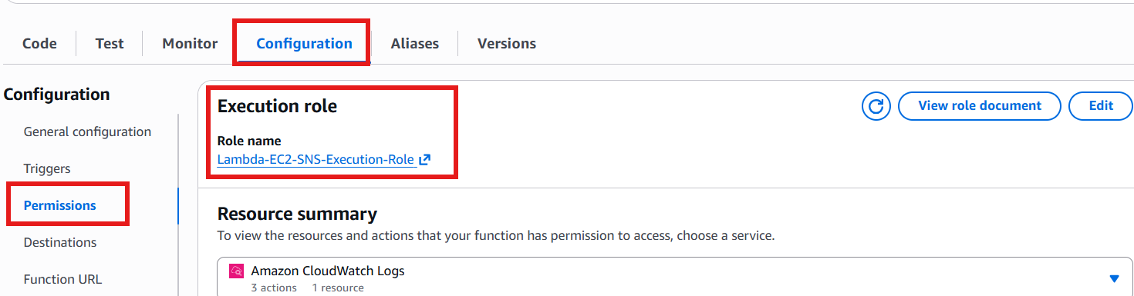

- Replace the default blueprint script in the code editor with the script below:
- import os
- import boto3

- # Initialize the SNS Client
- sns_client = boto3.client('sns')

- # Fallback to an environment variable for security, or pastethe ARN directly
- SNS_TOPIC_ARN = os.environ.get('SNS_TOPIC_ARN', 'arn:aws:sns:us-east-1:311925399650:EC2-State-Change-Topic')

- def lambda_handler(event, context):
- try:
- # Extract the instance ID and state from the native EventBridge event envelope
- instance_id = event['detail']['instance-id']
- state = event['detail']['state']
- region = event['region']

- # construct a clean, user-friendly alert message
- subject = f"Alert: EC2 Instance {instance_id} Changed State"
- message = (
- f"An EC2 instance state changes has been detected.\n\n"
- f"Instance ID: {instance_id}\n"
- f"New State: {state.upper()}\n"
- f"Region: {region}\n"
- )
- #Publish the state change details to the SNS topic
- response = sns_client.publish(
- TopicArn=SNS_TOPIC_ARN,
- Subject=subject,
- Message=message
- )
- print(f"Successfully processed notification for {instance_id}. MessageId: {response['MessageId']}")
- return {
- "statusCode": 200,
- "body": "Notification sent successfully!"
- }

- except Keyerror as e:
- print(f"Error prasing EventBridge payload. Missing key: {str(e)}")
- return {
- "statusCode": 400,
- "body": "Invalid event payload structured format."
- }

- except Exception as e:
- print(f"An Unexpected error occured: {str(e)}")
- return {
- "statusCode": 500,
- "body": "Internal notification failure."
- }

5. Click Deploy to Save Changes
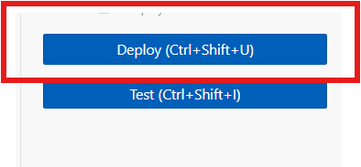

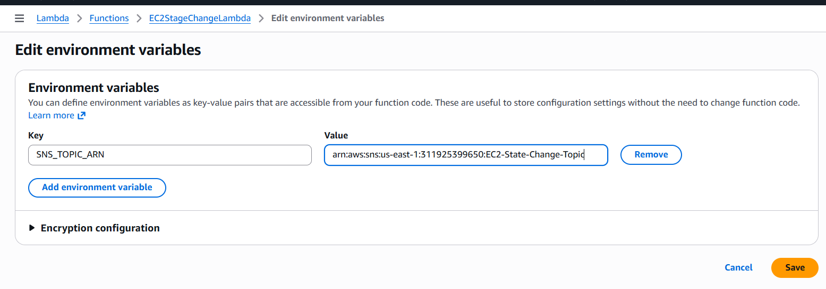

Configure Amazon EventBridge Rule
- Open the Amazon EventBridge Console.
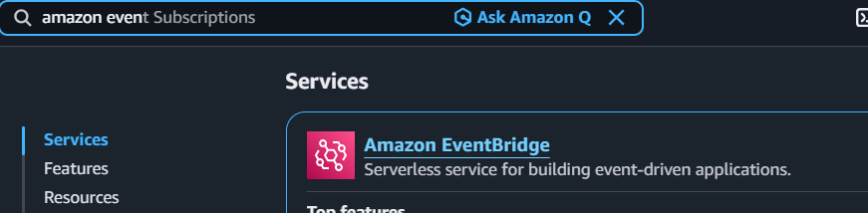

- Click Rules -> Create rule.
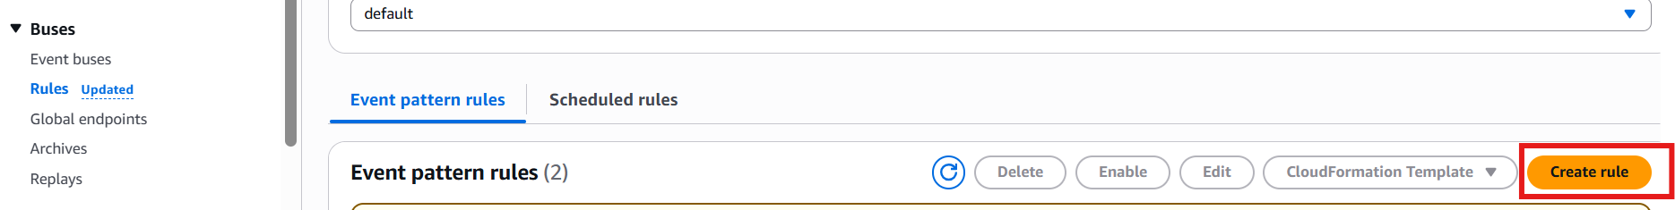
- Name the rule EC2-State-Changes and leave the bus as default. Select Rule with an event pattern.
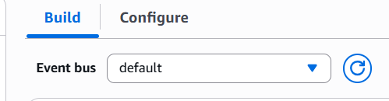
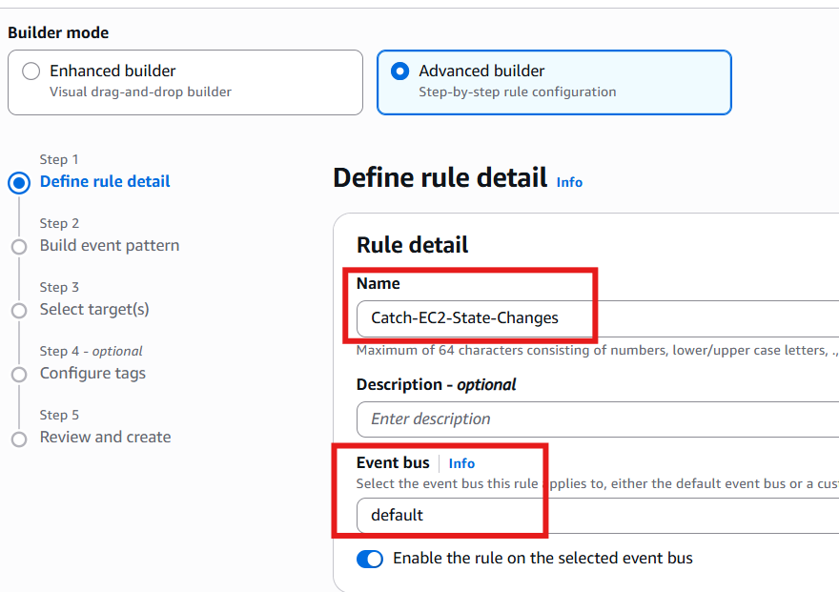
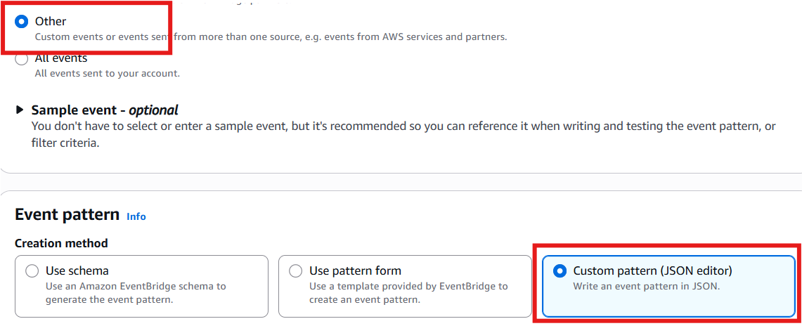

- Under Creation method, pick Custom pattern (JSON editor) and paste this specific filter pattern to filter for starts and stops:
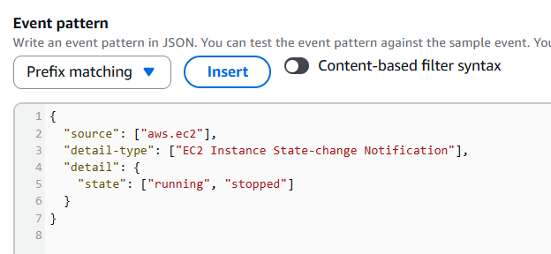

- Click Next. For Target types, choose AWS service, then pick Lambda function from the dropdown menu.
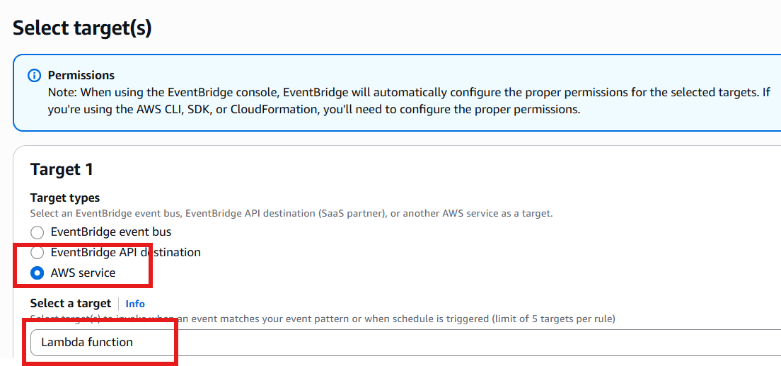
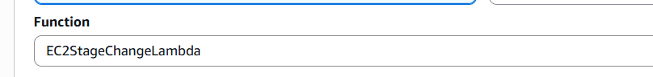

- Select the Lambda function name which is created.

- Click Next through tags, review the architecture mapping, and click Create rule.
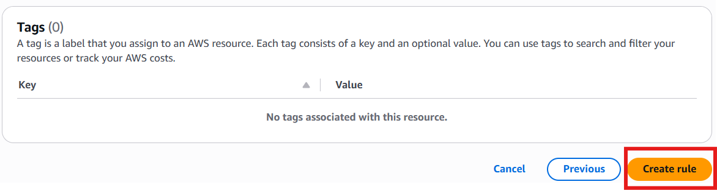

Test the End-to-End Workflow
- Head over to your Amazon EC2 Console.
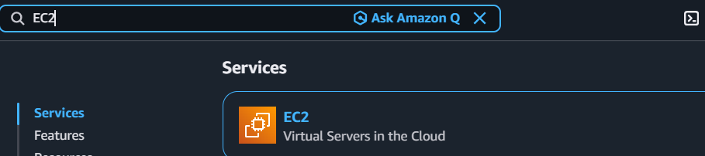
- Select any active test instance (or spin up a temporary micro-instance).
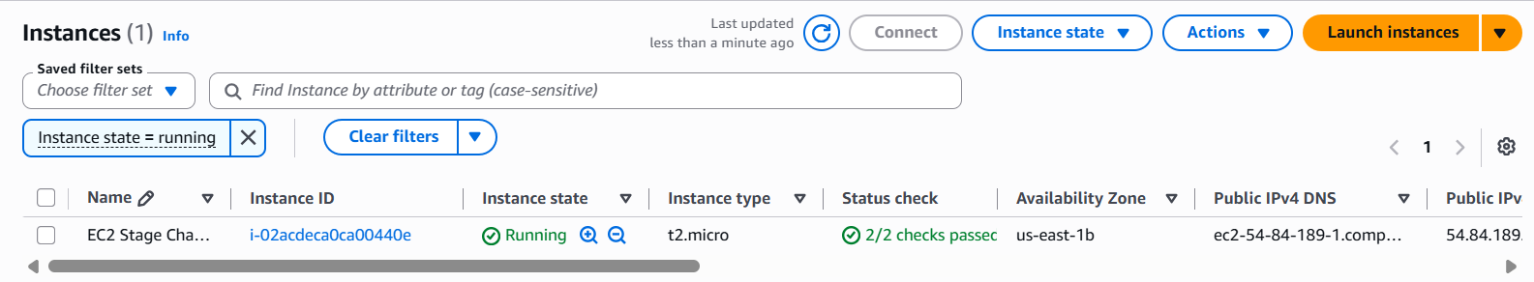
- Toggle its state by clicking Instance state -> Stop instance (or Start instance if it is currently stopped).
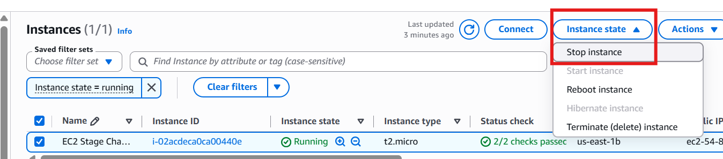
- Within a few seconds, verify that an execution is captured inside your Lambda function's CloudWatch Logs.
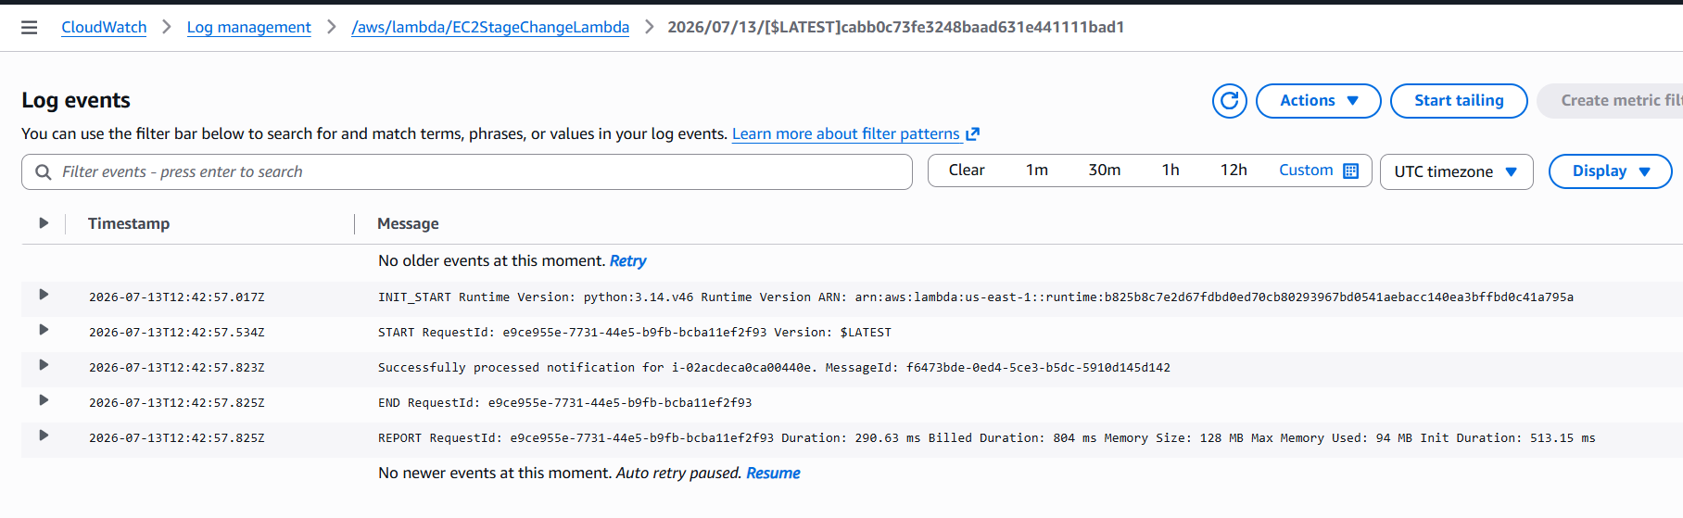

- I can check it in my email inbox for the structured message mapping out the specific instance ID along with its new status lifecycle environment.
